Thames Valley NWA

AGM Minutes – 24th July 2024

Location:
Zoom online meeting

Committee Members Present (year 2023/24):
Paul Adkins – AR & Chair
Phil Marsh – Treasurer (part-year)
Maggi Lewis – AR & Vice Chair (part-year)
Nick King - AR
Val McPherson - AR
Angela Money – AR
Paul Christmas – AR
Mabu Shaik -AR (departed 7:15pm)

Guest Speakers:
Supt John Batty – Thames Valley Police
Cheryl Spruce – Head of Membership & Community Engagement NW Network

Agenda:
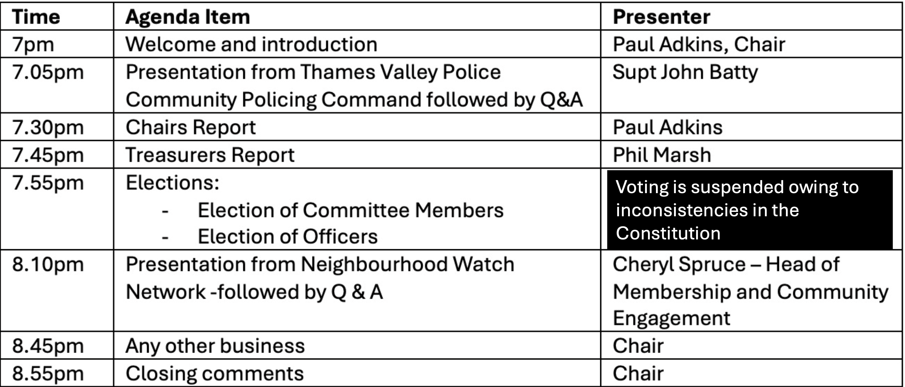

Minutes:

Welcome and Introduction
Paul Adkins welcomed the members to the AGM and announced that the 2023/24 committee will be standing down as set out in the terms of the current constitution. However, the re-election of Committee Members for the 2024/25 year will be deferred to an EGM when a new Constitution will be adopted (after a vote of members present at the EGM). The Area Representatives and the co-opted Treasurer will work together to produce a new Agenda within six months. Paul confirmed he would not stand as Chair for the 2024/25 period.

Presentation Thames Valley Police – Community Policing
NB: The presentation will be available at the end of July, along with the publication of the AGM video. Here are a few highlights delivered by Paul Adkins and Supt John Batty.

Superintendent's Presentation:

Paul offered his assistance due to his previous experience with the presentation content.

Community Policing Command and Strategic Plans:

Paul discussed the newly established Community Policing command, headed by Superintendent John Batty, which focuses on neighbourhood policing and other initiatives. The plan includes four main pillars: valuing people, building a central
community of police, increasing capability, and effective engagement. The "valuing people" pillar focuses on building a central community of police, including citizens in police, neighbourhood policing, and special constables. The plan also aims to increase the special constabulary to over 500 by 2028, with most of these officers deployed to neighbourhood policing. Paul reported on the Thames Valley Police's recent recruitment drive, funded by the Police and Crime Commissioner, which led to a substantial increase in the number of officers, particularly in neighbourhood policing. He also outlined the strategic plans for the next five years, including a focus on community policing and plans to tackle serious issues such as crime, race, and violence against women and girls, with the latter now being considered as serious as terrorism by the Home Office.

Thames Valley Police Strategy and E-Scooter Legality

Paul presented a comprehensive report about the Thames Valley Police's new strategy involving three control rooms, one for each county, and their collaboration with local authorities. On behalf of the online chat comments and questions logged by attendees to the meeting, Nick raised concerns about the legal ambiguity surrounding the use of E-scooters and the professionalism of call handlers, suggesting further inquiries to Superintendent John Batty. The team also discussed the importance of providing updates on reported incidents to callers. Lastly, Paul highlighted a useful tip about using incident reference numbers to inquire about the status of reported incidents.

Superintendent John Batty joined the meeting later in proceedings; what was discussed is detailed here for consistency.

Community Policing Demands and Future Plans

Paul introduced guest speaker John Batty, Superintendent of Thames Valley Police, who presented on the community policing demands in his area. John highlighted four main strands of work: neighbourhood policing, prevention, designing out crime, and hotspot policing. He also discussed the role of the Special Constabulary volunteers and Police Cadets. The team's progress and plans for collaboration and maximising efforts towards community policing were presented, with a focus on providing clarity and focus for the teams. Questions were raised about the complexity of plans, the issue of privately owned e-scooters, and the recruitment and training of control room staff. John clarified that the plan aims to double neighbourhood police officers but did not foresee an increase in PCSOs, acknowledging the challenges in dealing with the increasing demand for policing services.

CCTV System Proposal

A further online chat question related to how best NW members, or a member of the public can upload video images to TVP. John Batty confirmed this was possible but limited, given the compatibility of the systems used by individual businesses.

Nick is tasked with reviewing the complete online chat questions log and forwarding it to Superintendent John Batty for further follow-up if necessary.

Chair’s Report:
Paul reported on the organisation's successful growth over the past year, which was attributed to strengthened partnerships with various organisations, including Thames Valley Police, charities, and trading standards. He detailed collaborations with the police force, such as joint training sessions and neighbourhood watch initiatives aimed at reducing crime. Paul also highlighted the productive relationship with the Police and Crime Commissioner, which resulted in improved equipment and materials. He showcased the work of several team members, including Nick's impact on recruitment rates in Milton Keynes, Maggie Lewis's community work, and collaboration with the local council.

Organization Review and Restructuring Plans

Paul reported on the organisation's successful year and emphasised the need to improve efficiency in the future.

Treasurers Report:

Phil presented the final accounts for the previous year prepared by the outgoing Treasurer, David Marsh. There were no questions. Nick King proposed the adoption of the accounts, and this was seconded by Paul Adkins.

Elections:
It was decided not to hold elections for new officers due to constitutional inconsistencies, planning to review and restructure the organisation instead. Paul announced his decision to step down as Chair, expressing confidence in the committee's ability to function without a Chair.

Presentation from NW Network:
NB: The presentation will be available at the end of July, along with the publication of the AGM video.

Cheryl Spruce, the head of membership, engagement, and community engagement at the National Neighbourhood Watch Network, introduced her team and their respective roles. She outlined the organisation's work, including new projects, member packs, coordinator packs, and a knowledge hub for neighbourhood watch coordinators. Cheryl also highlighted the importance of succession planning, volunteer recognition awards, and resources for community members to prevent crime. She discussed awareness of the TVNWA and Thames Valley Police's collaboration with work with College of Policing for curriculum and training redesign.

AOB:
None

Closing comments:
Paul thanked everyone for their participation and introduced guest speakers Cheryl and John. The conversation ended with Paul expressing hope for more involvement in the team's efforts to combat crime.

