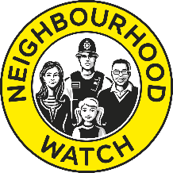
Accessing new members on Neighbourhod Alert

To access new requests from people wishing to join your scheme, follow the link https://ourwatchmember.org.uk/ , this will bring you to our new look member screen.
Fill in your login details, click on “I’m not a robot” and then click the big yellow LOGIN box. (If you have forgotten your login details, then click on forgotten password)

The members page will appear, and you will have several options, click on SCHEME ADMIN.

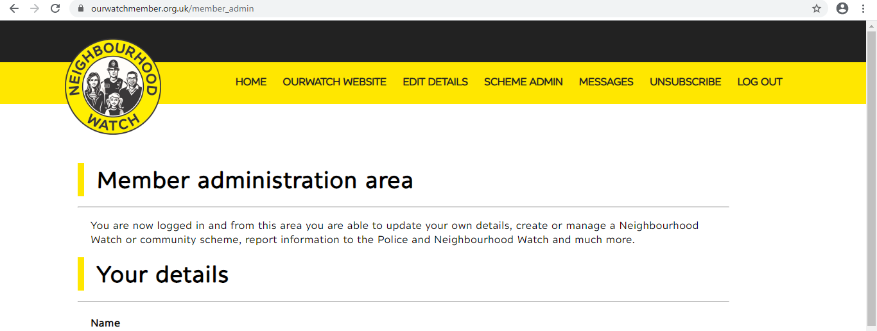

Scroll down the page to the bottom and select Approve new applicants

It will then take you to the page where anyone who has applied to be part of your scheme is listed. You may go through this list and click on approve to approve the new members.

As you may see from the menu above, there are several items on this list, which you can use, for instance, you can send all registered members an email from here as well.

Engaging new members

We have created the following welcome message, as an example, for you to share with your new members.

“Dear new member

Thank you for joining your local Neighbourhood Watch scheme. My name is _______________ and I am your scheme coordinator. My role is to act as a point of contact for our neighbours, share relevant information from our partners and other coordinators in the Neighbourhood Watch Network. To encourage engagement with our neighbours (currently through less traditional means, such as social media, telephone, email and video link), identify those that are vulnerable and isolated and reach out to them.

The safety of our community is one of the main reasons people join our movement and as such, my role is also to encourage you to report suspicious behaviour, crimes and scams to the most appropriate people.

Suspicious behaviour & Crimes 101 in non-emergency, 999 in an emergency
0800 555111 or www.crimestoppers-uk.org – Report anonymously via CrimeStoppers
Scams - Action Fraud 0300 123 2040 or www.actionfraud.police.uk

Being part of Neighbourhoud Watch also means looking out for our neighbours and being neighbourly. Although we are all socially distancing ourselves from each other, we encourage different ways of being neighbourly to our neighbours.

Our central network is currently partnered with Mutual Aid and part of the Community Action Response during this crisis and we are encouraging our members to reach out to local volunteer groups, which are already established, as part of our county’s local resilience planning. To find out more information please visit their website www.ourwatch.org.uk . We are also encouraging members to keep an eye on each other’s homes and possessions, giving special consideration to supporting vulnerable neighbours.

These are challenging and unprecedented times for us all and we, as many others, are finding our way. I think, as a community, working together to keep safe and following the current advice from our government and health officials, we can come through this together.

Thank you once again for joining our scheme and I look forward to engaging with you more in the coming days, weeks and months.

Please contact me by: Insert email address and/or phone number

Keep safe

(enter your name)”

